1. **Data Narratives**
2. **Story Mapping**
3. **Audience Analysis**
4. **How to Run Q&A**
5. **Providing Feedback**

**DATA NARRATIVES**

To create a strong data narrative, look to popular story structure. You can diagram any story or presentation by taking note of the following components:

**Setting, time, place:**

* Where does the story take place? Where was the data collected?
* When does the story take place? When was the data collected?

**Characters:**

* Who (or what) is the data about? Who (or what) does it describe?
* Who is the presentation for? Who is the audience you are trying to convince?

**Problem:**

* What is the motivating question or situation?
* What are the underlying dependencies, if any?
* Identify the structure of the constituencies involved.

**Plot/Events:**

* How did you collect the data?
* How did you modify/clean the data?
* What type of analysis did you do?
* What are the findings of your research/analysis?

**Resolution**

* What are your conclusions?
* What are your recommendations for next steps, based on your findings?

Strong presentations have all the elements of a great story. When outlining your presentation, try organizing your information into story-like categories to help you better plan your overall narrative. Doing so will provide a framework that your audience members will generally be accustomed to while also preventing you from missing important details in your presentations.

**STORY MAP**

But how do you write a data story? Consider the structure of traditional and nonlinear narratives. Note the arcs that they follow and consider outlining your presentation in a similar fashion.

**LINEAR: INFORMATIONAL**

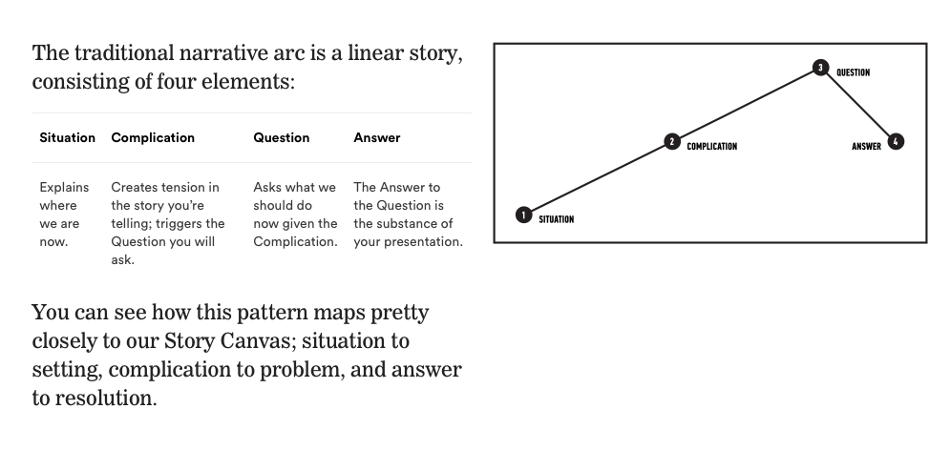

This pattern puts the audience in a narrow context, posing your findings as a specific solution that shows how your efforts have made an impact:

* Start by explaining the specific situation
* Add some tension by dramatizing a specific problem
* Pose some hypothetical questions about how this might be resolved
* Demonstrate how your approach and findings help resolve the problem

**NON-LINEAR: PERSUASIVE**

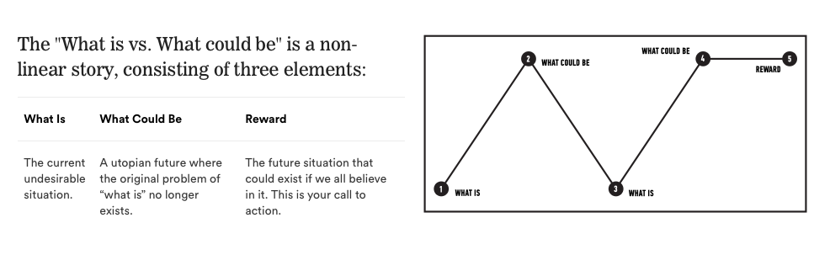

This pattern sets up a broad context, outlining a vision of what your approach makes possible if the audience takes your findings further and acts on them:

* Begin by describing a current problem
* Outline the potential impact of a future where this problem has been solved
* Create a call to action based on your data to involve the audience in your findings

To make sure your presentations are most productive and effective, always consider how you are framing the *story* of your analysis. A great presentation should tell a story that meets your audience’s needs while informing them about or persuading them to act on your own results.

**AUDIENCE ANALYSIS**

It is vital for a data analyst to communicate to their audience that they have listened well and heard any concerns, and then demonstrate an ability to dissect these issues, bring up relevant information or criteria, and suggest a persuasive solution based on the relevant data.

To help understand the potential needs of your audience, try making use of the following tool when outlining your presentation. The Presentation Canvas provides a structure for considering the goals and objectives of your audience stakeholders, so that you can account for them in your delivery.

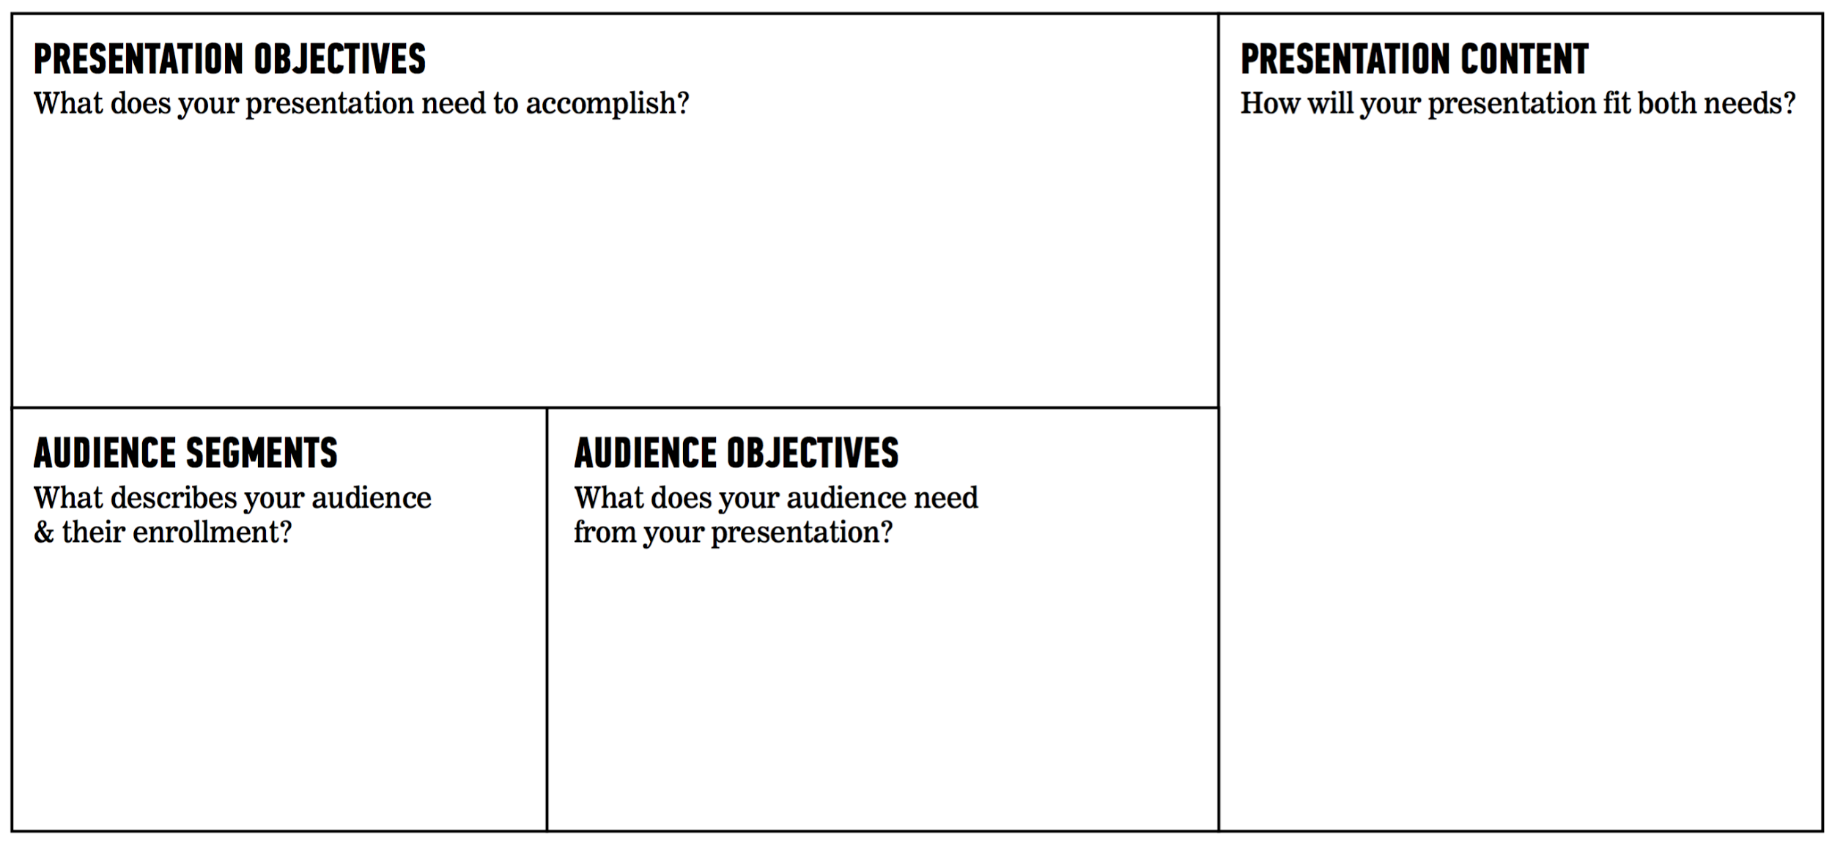

For a truly persuasive, impactful presentation, your goal should always be to convey your information *in a way that meets the needs and expectations of your audience*.

**HOW TO RUN Q&A**

**Clearly Limit Time:**

Before your presentation, indicate a specific portion of time for Q&A.

* For example, let the audience know ahead of time that you’ll reserve 5-10 minutes for Q&A.
* Remind the audience of those time limits and stick to them. If concerned about going over, prompt the audience for a “last question” to indicate closure.

If you’re taking questions during or after your presentation, try using leading questions, rather than open ended responses. Leading questions can help you steer audience interest towards areas that can be readily answered with your data. Here are some examples:

* *Open*: “What data are you interested in?”
* *Leading*: “Which census tract should I pull up here?”

**Anticipate Your Audience:**

When preparing for a presentation, think of answers to common questions ahead of time.

* “What was the most surprising finding you had?”
* “What other variables would you like to have had for your analysis?”
* “What are the next steps? What would you suggest for future analysts?”

To help yourself anticipate questions, you’ll need to really know your audience. Try brainstorming from an audience member’s perspective, test your presentation on a sample audience member and note their questions, or keep a log of audience questions from different presentations over time.

**PROVIDING FEEDBACK**  
  
When evaluating a presentation, try using some of the following tips to structure your feedback:

* Did the presentation answer all of the stakeholders question(s)?
* Was the story supported by data? Was the story arc a good fit for the analysis?
* Was the evidence for any correlations and deductions clearly supported by the data?
* What went well with the presentation? What did not?
* Were there any elements that were distracting or off topic?
* How did the Q&A go? Were questions well received and navigated?
* Was the story compelling? Thinking back on the presentation, can you recall the setting, problems, and solutions?